**Project Design Phase-II**

**Technology Stack (Architecture & Stack)**

|  |  |
| --- | --- |
| Date | 28 October 2022 |
| Team ID | PNT2022TMID09823 |
| Project Name | Signs with Smart Connectivity for  Better Road Safety |
| Maximum Marks | 4 Marks |

**Technology Architecture:**

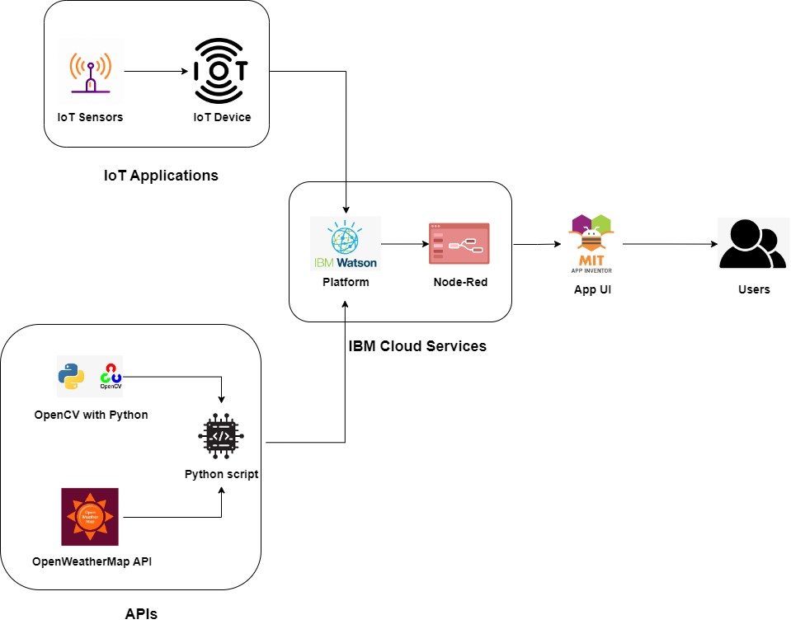

**Table-1 : Components & Technologies:**

|  |  |  |  |
| --- | --- | --- | --- |
| **S.No** | **Component** | **Description** | **Technology** |
| 1. | User Interface | User can interact with the app using MIT App | HTML, CSS, JavaScript / Angular Js / React Js |
| 2. | Application Logic-1 | Logic for a process in the application | Java / Python |
| 3. | Application Logic-2 | Logic for a process in the application | IBM Watson STT service |
| 4. | Application Logic-3 | Logic for a process in the application | IBM Watson Assistant |
| 5. | Database | Data Type, Configurations etc. | IBM Cloud |
| 6. | Cloud Database | Database Service on Cloud | IBM DB2, IBM Cloudant etc. |
| 7. | File Storage | File storage requirements | IBM Block Storage or Other Storage Service or Local Filesystem |
| 8. | External API-1 | Purpose of External API used in the application | Open Weather Map API |
| 9. | External API-2 | Purpose of External API used in the application | IBM Watson Platform , Node - Red |
| 10. | Machine Learning Model | Purpose of Machine Learning Model | OpenCV |
| 11. | Infrastructure (Server / Cloud) | Application Deployment on Local System / Cloud Local Server Configuration:  Cloud Server Configuration : | Local, Cloud Foundry, Kubernetes |

**Table-2: Application Characteristics:**

|  |  |  |  |
| --- | --- | --- | --- |
| **S.No** | **Characteristics** | **Description** | **Technology** |
| 1. | Open-Source Frameworks | OpenWeatherMap , NODE-RED, IBM WATSON, MIT App Inventor | IoT, internet |
| 2. | Security Implementations | Powerful security system for everyone's peace of mind  No access data Hackers cannot access network | Firewall, Firebase, cyber resiliency,strategy |
| 3. | Scalable Architecture | EASY TO EXTEND THE NETWORK WITH THE  AID OF THE BANDWIDTH OF THE NETWORK | IBM Cloud |
| 4. | Availability | Available every time and everywhere 24/7 so long as the consumer is signed into the network. | IBM Cloud |
| 5. | Performance | AIDS MASSIVE RANGE OF USERS TO USE  TECHNOLOGY | IBM Cloud |